23.87: Angular momentum and energy must be conserved, so:
Substituting in for 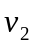 we find:
